Digital Logic Lab 1 Report

Digital Logic 2116L

1/30/2018

Featheringill 210

Suyi Diao, Bryce

1. Introduction:

The basic concepts we learned for this lab are Ohm’s Law, logic gates and TTL gates. Through this lab, we are trying to learn how to construct basic logic expression through the usage of TTL gates.

1. Design Requirements:

Firstly, we need to build a given diagram using breadboards and multi-meter, the diagram is shown below:

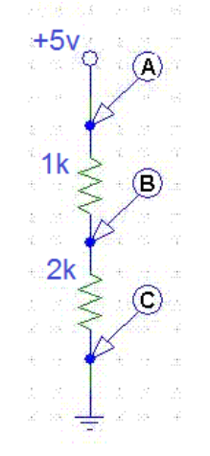

Secondly, we need to build a circuit that translates to the following logic using TTL gates:

g=XZ + YX + YZ

1. Diagrams

First part of the lab is constructed exactly using the diagram provided in the prelab.

Second part of the lab’s diagram is shown below

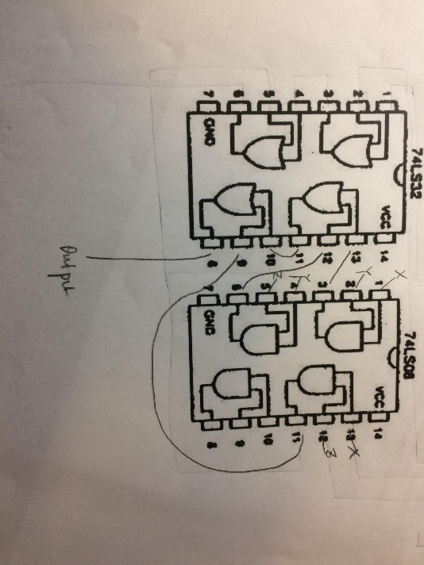

1. Results

First part of the lab asks us to measure the voltage at A, B and C.

Voltage at A is measured as 5.06V

Voltage at B is measured as 3.35V

Voltage at C is measured as 0.2V

Second part of the lab were finished in time and the output was coherent with the theoretical truth table shown below

|  |  |  |  |
| --- | --- | --- | --- |
| X | Y | Z | F |
| 0 | 0 | 0 | 0 |
| 0 | 0 | 1 | 0 |
| 0 | 1 | 0 | 0 |
| 0 | 1 | 1 | 1 |
| 1 | 0 | 0 | 0 |
| 1 | 0 | 1 | 1 |
| 1 | 1 | 0 | 1 |
| 1 | 1 | 1 | 1 |

1. Discussion

Only issue that arise in the lab was the physical expression of a 0 input. We initially thought not plugged in means 0, but as it turns out, plugging into the ground means 0 and we got stuck because of this for a very long time.

We had this problem because we had no previous knowledge of the physical circuit and we will do our research first starting next lab

1. Conclusion

I learned how to measure voltage using multi-meter and how to construct logic gate using TTL gates. I like all parts of this lab.

1. Post-Lab Questions
2. What were you expecting from the voltage between the two resistors?

Somewhere around 3.5V since the input was 5V and the first resistor was 1k Ohm.

1. Did the result deviate from what you expected? Why?

It did not deviate much, the deviation come from the resistance of the wire.

1. How did you check to make sure that your circuit worked correctly?

Using the truth table, we calculated the output of the function by hand first and then test each input of the truth table.